COMMERCIAL
PERFORMANCE HUB
Master Portfolio Case Study
Executive Reporting → Commercial Insight → Decision Engine
Dip Panchal
Power BI • DAX • SQL / MySQL • PBIP • GitHub
Public repository: https://github.com/dipgpanchal/Commercial-Performance-Hub-PBIP

1. Executive Summary
Commercial Performance Hub is a Power BI reporting and analytical solution supported by a MySQL ELT layer. It brings sales, profitability, pricing, product, store and inventory analysis into a unified decision-support experience. The design takes users from executive performance monitoring, through investigation of commercial drivers and risks, to controlled scenario testing.
The project is a portfolio build intended to demonstrate commercial analytics, data transformation, Power BI, DAX, scenario modelling, source control, quality checks and technical documentation. It does not claim realised financial savings, revenue improvement, adoption or production business impact.
Repository: https://github.com/dipgpanchal/Commercial-Performance-Hub-PBIP

2. Intended User Journey
- Executive Reporting — What is happening? Review KPIs, trends, category and store performance, and key business insights.
- Commercial Insight — Why is it happening? Investigate product, category and store performance, identify drivers, and explore potential risks and opportunities.
- Decision Engine — What could we do? Test price, cost, volume and elasticity assumptions and examine potential revenue, profit and margin impacts.

3. Solution Capabilities

Executive Reporting
Provides KPI comparisons and trends, top and bottom categories, stores and products, and a Key Business Insight area to help users identify where deeper investigation may be useful.

Commercial Insight
Supports product, category and store performance analysis, including contribution, trend and variance views to help investigate performance drivers and potential commercial opportunities.

Inventory Health
Uses an eight-week demand window and defined business rules to classify store/product inventory positions. Weeks Cover = Stock on Hand ÷ average weekly units sold over the last eight weeks. Suggested actions are decision-support guidance and require operational confirmation before execution.

Scenario Planner and Price Sensitivity
The Scenario Planner exposes four inputs: Price Change %, Cost Change %, Volume Change % and Elasticity. Effective volume change combines the selected volume assumption with the price-change × selected-elasticity component. Price Sensitivity similarly uses selected assumptions to explore potential outcomes. These calculations are what-if scenarios, not statistically validated demand models or causal forecasts.

4. Data Architecture and ELT
The Power BI model imports source and analytical tables from the MySQL reporting schema named practise. The described pipeline separates raw source data, transformations and reporting-ready structures. The project documentation should be read alongside the repository because upstream SQL DDL and view-creation scripts were not included in the case-study version reviewed.
- Source data: Products, Stores, Sales and Inventory CSV files.
- MySQL raw layer: source data loaded for extraction and staging.
- Transformation layer: cleaning, type conversion and commercial calculations.
- Reporting structures: dimensions, facts and analytical views including vw_fact_product_weekly.
- Power BI semantic model: relationships, measures, calculation group and field parameters.
Standard calculations include Revenue = Units × Unit Price; Cost = Units × Unit Cost; Profit = Revenue − Cost; and Unit Profit = Unit Price − Unit Cost.

5. Semantic Model and SQL Analytics
The case-study version records a model inventory of 36 tables, 9 relationships and 274 measures, including a Comparison calculation group with four calculation items and field parameters. These counts should be reconfirmed against the public repository before publication.
The weekly product view vw_fact_product_weekly aggregates product sales by week and calculates weighted average unit price, cost and profit, transaction counts, prior-week comparisons, percentage changes and an empirical price-elasticity calculation. This empirical week-over-week calculation is distinct from the Decision Engine’s user-defined scenario assumptions.
The rolling analytical views are described as prepared for future requirements, rather than as confirmed inputs to current report visuals or measures.

6. Development, QA and Personal Contribution
The portfolio covers solution design, the business decision journey, MySQL ELT transformations, dimensional structures, Power BI semantic modelling, DAX measures, Inventory Health rules, Scenario Planning, Price Sensitivity, report build, QA, PBIP/Git structure and documentation.
The workflow emphasises feature branches, review of git status and diffs, manual Power BI validation, change records, selective staging, staged-diff review and controlled commits. Copilot was used as an assistive tool for learning, troubleshooting, targeted impact analysis and documentation; design decisions and validation remained under the author’s control.
- Data QA checks described in the project include row counts, duplicates, nulls, referential integrity, sales-total reconciliation, product matching and store matching.
- QA claims should be limited to documented checks and manual validation; the case study does not claim an independently reproduced or automated test suite.

7. Technology Stack
Power BI Desktop / Service • DAX • Power BI semantic model • SQL / MySQL • PBIP • Git / GitHub • feature branches and pull requests • Markdown documentation • GitHub Copilot-assisted development.

8. Data Provenance and Limitations
The portfolio uses a toy-sales dataset described in project materials as the Mexico Toy Sales dataset. The exact source URL, creator attribution, dataset status and licence or redistribution permissions were not verified in the source case study. Confirm these details before public release.
The inventory field fact_inventory_snapshot.load_dt records when data was loaded into MySQL; it is not established as the physical stock observation date. Scenario outputs are illustrative, assumption-based estimates and must not be presented as validated forecasts.

9. Project Summary
Commercial Performance Hub is an end-to-end Power BI commercial analytics portfolio project combining a MySQL ELT layer, dimensional semantic modelling, DAX measures and interactive scenario analysis. It demonstrates a structured approach to moving from performance monitoring to commercial diagnosis and assumption-based decision support, with source control, QA and documentation practices.

Project repository
https://github.com/dipgpanchal/Commercial-Performance-Hub-PBIP

Appendix A — Executive Summary

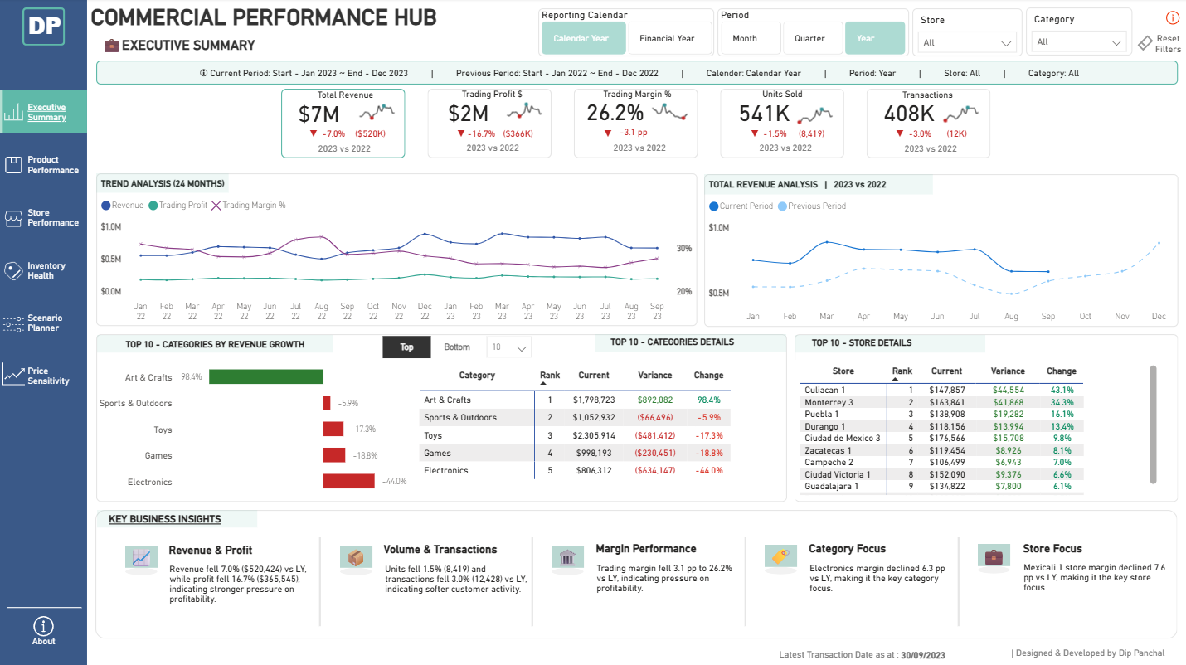
KPI comparison, trend analysis, category/store performance and key business insights.
Screenshot reproduced from the supplied V9 case study. Confirm that it matches the current public-main report before public sharing.

Appendix B — Product Performance

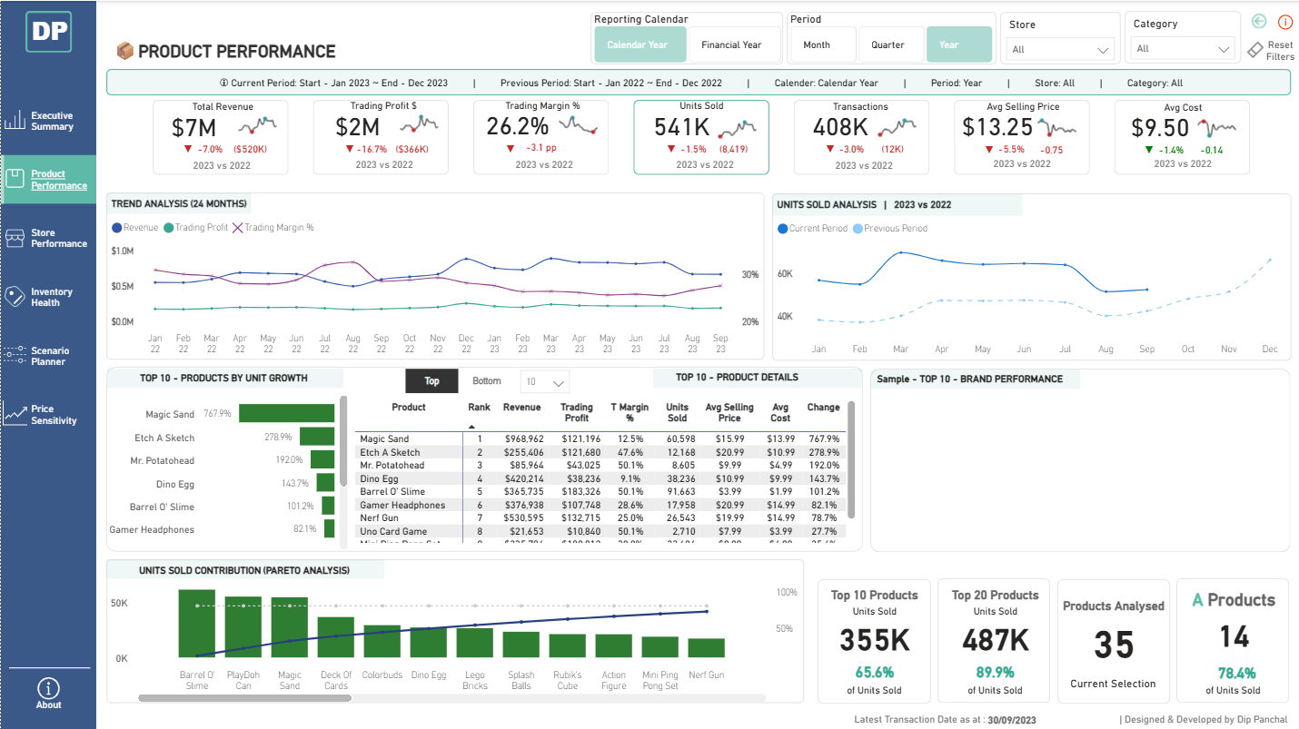
Product growth, product details and unit contribution analysis.

Appendix C — Store Performance

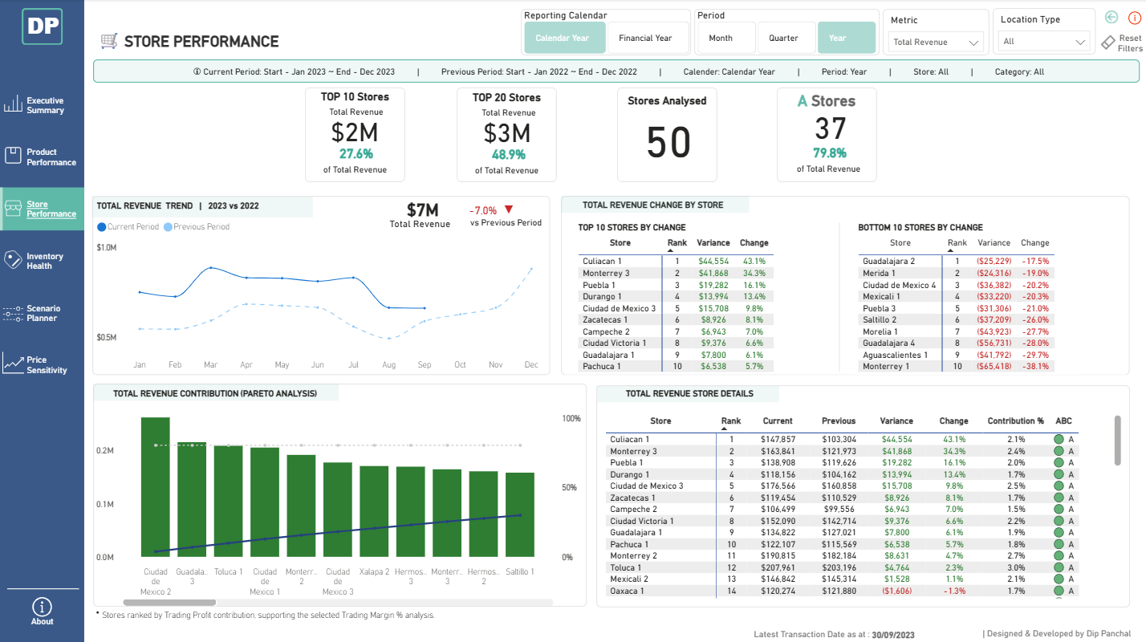
Store contribution, top/bottom performers and revenue movement.

Appendix D — Inventory Health

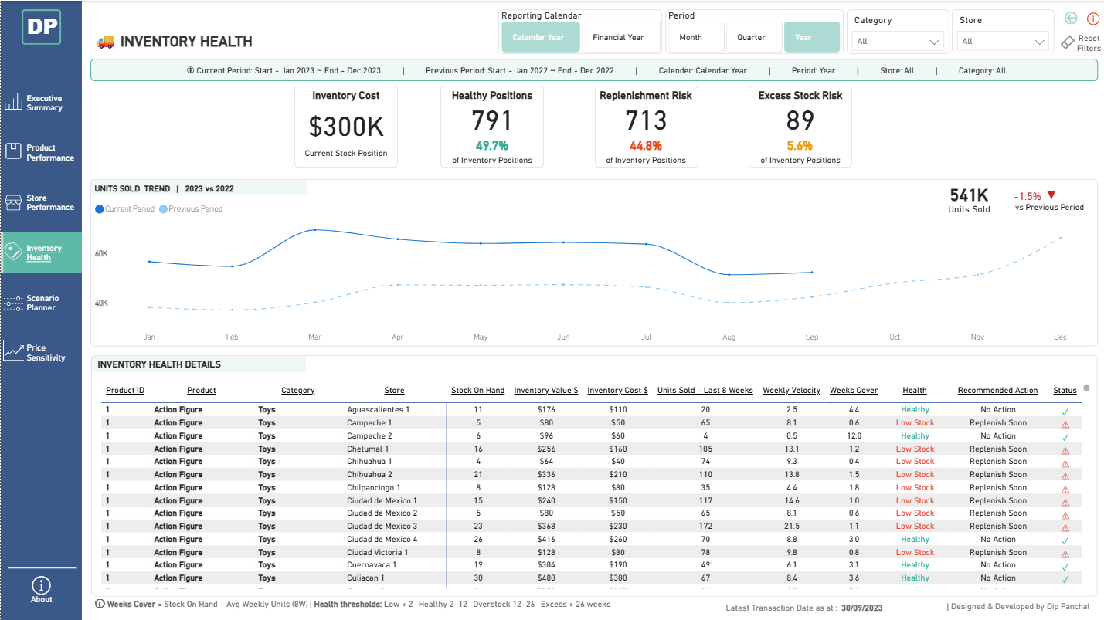
Stock positions, eight-week demand context and recommended actions.

Appendix E — Scenario Planner

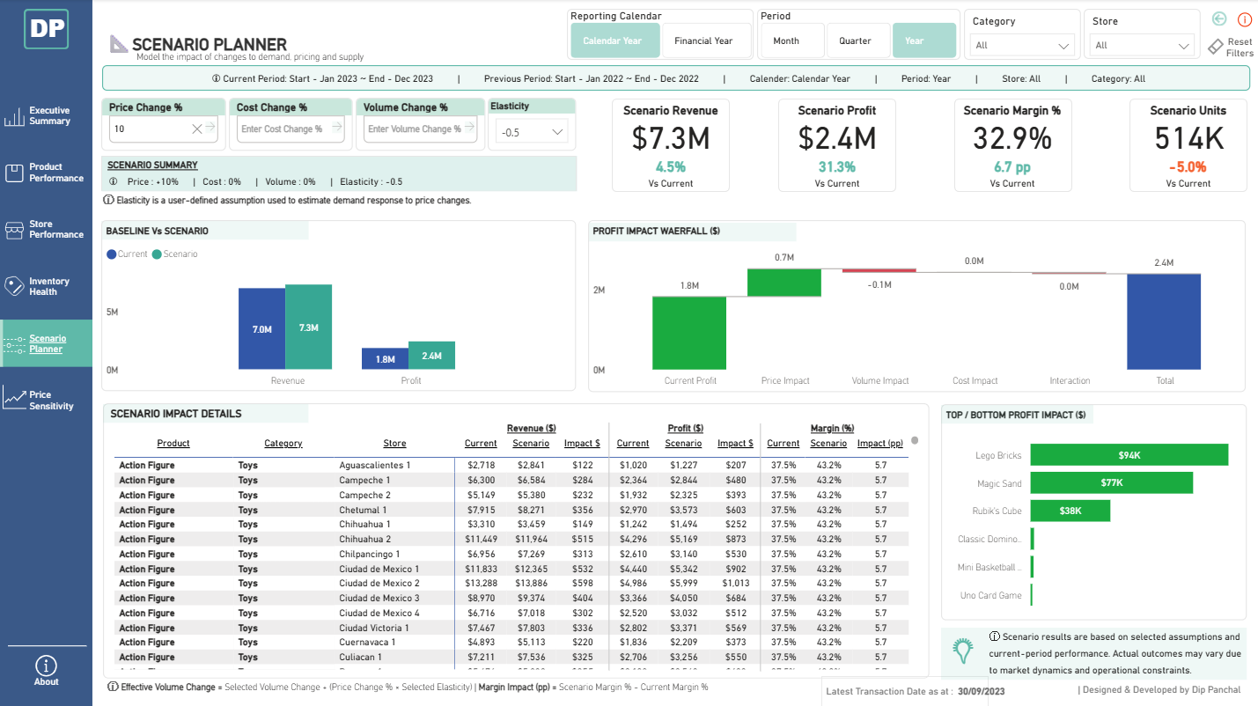
Price, cost and volume assumptions with potential revenue, profit and margin impacts.

Appendix F — Price Sensitivity

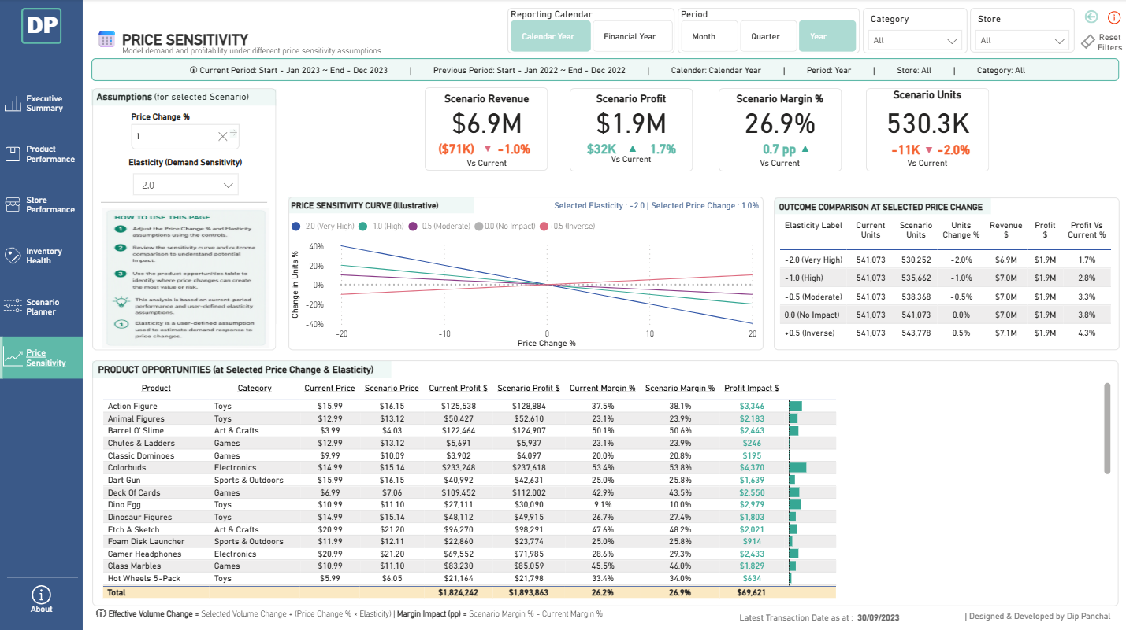
Selected elasticity, demand-response curve, outcome comparison and product opportunities.

